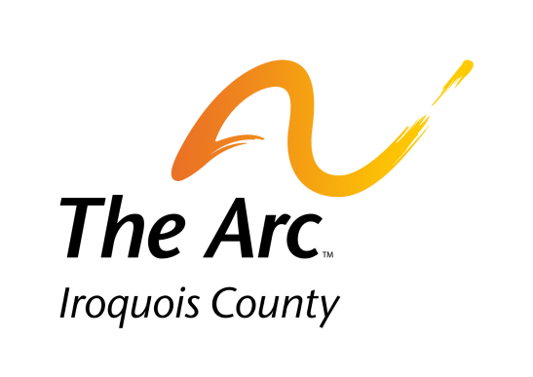

DEPARTMENT: | CILA
REPORTS TO: | CILA Manager
STATUS: | Non-Exempt (Hourly)
DATE: | 2/11, Revised 4/12  Revised 4/18

Commitment of All Employees
All employees of The Arc of Iroquois County are expected to demonstrate commitment to the Mission of The Arc in our service to adults with disabilities and their families and to the community at large. All employees are responsible to be familiar with and follow the Best Practices of the organization and its programs. All employees will endorse and work with the parameters of the Employee code of Ethics. All employees will demonstrate support of the events and activities

PRIMARY JOB OBJECTIVE: The CILA Direct Support Professional (DSP) will ensure a safe environment for people receiving CILA services and support them to achieve their goals most important to them in the community and at work.

QUALIFICATIONS - The CILA DSP must:
- Have an intense desire to work with and for people with developmental disabilities, their families, and the staff who support them in carrying out all aspects of this job.
- Be of good moral character, honest, reliable, responsible and trustworthy
- Have a high school diploma or a GED
- Show competency at least at an 8th grade level in reading on the Test of Adult Basic Education (TABE)
- Successfully pass a pre-employment drug screening
- Successfully pass a criminal background check through the Illinois State Police or have a Department of Public Health Waiver.
- Have clearance through the Illinois Department of Public Health Nurse Aid Registry
- Possess and maintain a valid Driver’s License with a clean driving record
- Successfully complete the 120-hour DSP Training within three (3) months of employment.
- Successfully complete Medication Administration Training within six (6) months of employment if you are a high school graduate or hold a GED and are at least eighteen (18) years old.
- Maintain an effective working relationship with people supported, families, staff, community service agencies and outside providers
- Have the ability to complete all training including CPR, 1st Aid and behavior management.
- Provide proof of current insurance on their vehicle.

PHYSICAL DEMANDS
- Refer to Employee Handbook regarding lifting guidelines and restrictions

ESSENTIAL DUTIES AND RESPONSIBILITIES – The CILA DSP will assist each individual as applicable with the following:
- Paperwork:
  - Initiate outcome plans (OPs), assist others to improve on OPs and accurately document results
  - Replace Data Collection sheets as needed
  - Initial schedules/changes
  - Properly call in and out at the beginning and end of each shift
  - Record special events and informal activities
  - Function as part of the team by submitting input for their annual meeting, attending meeting and ensuring recommendations in the service plan are implemented
  - Check mailbox, bulletin boards and communication logs daily for messages
  - Document pertinent information in communication log at beginning of day

- Community:
  - Pop money, noon medications, communication logs and communication devices to site sites as needed
  - Provide transportation as requested or assigned
  - Assist people supported with integrating into the community (small group or one-on-one activities) to provide meaningful activities and experiences
  - Assist people supported in maintaining family and community contacts
  - Assist people supported in grocery and personal shopping
- Medical:
  - Basic first aid care
  - Do vitals – B/P, weights and temperatures
  - Fill out Incident Reports (IRs) and document in UNB
  - Fulfill medication trainings no later than within two (2) weeks, unless assigned otherwise
  - Administer medications, treatments, special/medical needs (urostomy, colostomy, etc.) as ordered/trained to do
  - Medication & Treatment Review sheet signed off by physician, neurologist or psychologist
- Safety:
  - Ensure Disaster Preparedness & Fire Drills are completed accurately per schedule and as requested
  - Change batteries in smoke detectors, carbon monoxide detectors (if battery operated) emergency radio, and flashlights (when time changes – March and November)
  - Daily water temperature checks
  - Maintain a safe and sanitary environment by assisting with the cleaning checklist at the level needed
  - Ensure health meals are prepared/provided that follow dietary requests/orders
  - Document nightly (11-7) safety monitoring
- Other:
  - Make sure vehicle at site is cleaned inside and out at least monthly
  - Assist with personal care and daily living skills at the level of support needed
  - Utilize current evaluation to improve supports and services
  - Maintain a cordial work climate promoting teamwork
  - Promote working across programs and other CILA homes
  - Attend and actively participate in team meetings as scheduled
  - Completed required training as scheduled
  - Assist people supported with documentation (medications, outings, releases)

JOB EXPECTATIONS – The CILA DSP will:
- Recognize the importance of friends, family and community relationships for the people we support, and be knowledgeable about techniques to support relationship-building among these groups.
- Demonstrate the skills necessary to build effective professional relationships with co-workers; be self-motivated, able to be self-critical and able to offer and receive constructive professional criticism.
- Live The Arc’s mission and philosophy, always seeking strategies for the organizational improvement of the team.
- Utilize mandatory team meetings as a training opportunity for both staff and people supported, encouraging open and honest communication and creating a culture that knows and supports what people want in services.
- Utilize effective communication skills and basic counseling strategies to build self-esteem and enhance self-determination in the people we support while not taking verbal/physical confrontations personally.
- Follow best practices and ensure they are utilized and available to people supported.
- Know and consistently follow emergency/safety procedures to ensure the health, safety and welfare of all people, staff and property in all environments
- Professionally and effectively respond to all behavioral needs

ACKNOWLEDGMENT:
The statements herein are intended to describe the general nature and level of work being performed by the employee in this position. The content of this job description is not intended to be construed as an exhaustive list of all responsibilities, duties, and skills required of an employee in this position.

I acknowledge and understand that:
- Receipt of the job description does not imply nor create a promise of employment nor an employment contract of any kind, and that my employment is at-will.
- The job description provides a general summary of the position in which I am employed, that the contents of this job description are the job requirements and, at this time, I know of no limitations which would prevent me from performing these functions with or without accommodation. I further understand that it is my responsibility to inform my supervisors at any time that I am unable to perform these functions.
- Job duties, tasks, work hours and work requirements may be changed at any time.

_________________________________________
Employee Name (print)

_________________________________________
Employee Signature (date)

The Arc inspires and empowers individuals to pursue opportunities to live their lives to the fullest.

Job descriptions/cila.adsp.418 gmb

